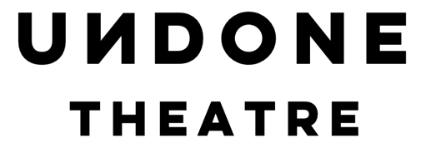

LONDON / LONDRA

A weekend of events and workshops exploring queer history and migration in London
21-22 January 2023 - Queercircle

SUMBISSION CALLOUT

We are looking for 10 artists working in any discipline to submit work as part of our upcoming project LONDON/LONDRA. Whether you’re a writer, a visual artist, performer, or work in any other discipline, we’d like to hear from you! We are looking for work that engages with queer/migrant experiences in London.

Selected artists will receive a £75 honorarium as well as an opportunity to share their work during an in-person open mic at Queercircle, on 22 January 2023. All selected entries will also be documented in an upcoming zine. We are keen to receive submissions from queer and/or migrant artists, however applications from artists of any background are welcome.

GUIDELINES:
We want to keep these guidelines as open as possible to encourage artists from any discipline to apply and to receive exciting, outside-of-the-box ideas. As your work will be shared during an in-person event, we only ask that your proposed piece is no longer than 7 minutes and, if in writing, no longer than 1-2 pages (or 500 words).

Your work will also be featured in an upcoming zine. We understand that not all artforms can easily be adapted to this format, so we’re open to discussion on how we can best adapt your piece from one medium to the other.

LONDON/LONDRA is a curated weekend of free creative workshops and events exploring queer and migrant experience in London, hosted at Queercircle in January 2023. It is a provocation to reimagine urban life, belonging, and ideas of the ‘local’ by centring queer/migrant histories and experiences.

LONDON/LONDRA is inspired by Gabriele Uboldi’s digital piece of the same title. You can have a look at their work for some inspiration: www.london-londra.com

HOW TO APPLY:
Please fill out this application form: https://forms.gle/7hz35csFXMnRwYF9A

Deadline: 31 December 2022, 5pm

Our team will review all applications and get back to all applicants by 10 January 2023. Selected applicants will share their piece as part of LONDON/LONDRA at Queercircle on 22 January 2023, 4pm.

If you have any questions, please get in touch with Gabriele Uboldi at gabriele@undonetheatre.co.uk.

We’re looking forward to receiving your work!

